1. **SDLC Phases:**
2. **Analysis:** The process of analyzing something in order to better understand it, whether it is a summary or a detailed explanation of the requirements of a project to be implemented.

There are 4 main functions performed by analysts:

* Product Owner: is responsible for managing and optimizing the product backlog to maximize the product's value.

They are many roles in the product owner, the most important:

* Clearly identify product backlog and list all items clearly.
* Prioritize the product backlog and arrange them in the correct order so that important tasks are given first for the highest priority.
* Prioritize work items and product backlog, this must be in line with customer vision and goals.
* Evaluate the work done by the development team and provide constant feedback.
* The tools of product owner
* Backlog
* Product road mapping
* Project managers: are organized, goal-oriented professionals who use innovation, creativity, and collaboration to lead projects that make an impact.

Here are some of the critical soft skills that PMs need to excel in their role:

* **Communication**
* **Adaptability**
* **Problem-solving**
* **Team leadership**
* **Organizational skills**
* The tools of project managers:
* **Software testing**
* Jira
* Trello
* **Business analyst: is help guide businesses in improving processes, products, services, and software through data analysis.**

**These agile workers straddle the line between IT and the business to help bridge the gap and improve efficiency.**

**There are several responsibilities that business analysts perform, which are:**

* **Creating a detailed business analysis in an effort to outline problems,**

**opportunities, and solutions for a business**

* **Budgeting and forecasting**
* **Planning and monitoring**
* **Variance analysis**
* **Pricing**
* **Reporting**
* **Defining business requirements and reporting them back to stakeholders**
* The tools of **Business analyst:**
* **Business process modeling**
* **Project management**
* **CTO: is an executive who determines an organization's technology strategy**

**While the role can vary depending on the size of a company, a CTO typically:**

* **Oversees all aspects of technology**
* **Establishes the various roles**
* **Creates policies**
* **Researches and develops**
* **Continuously educate**
* **Analyzes data**
* **Keeps up to date**
* **Ensures data privacy**
* **Communicate technology strategies**
* **Monitor budgets**

1. **Design:** is a stage where software developers define the technical details of the product.

These details can include screen designs, databases, graphics, system interfaces, and prototypes based on project requirements.

The design includes two basic functions:

* System architects Design of IT systems framework based on the request of the technical management of projects

As companies build more networks, the demand for system architects will increase because they are the key people who plan how different devices will work within a system. To do so, they:

* Work on the overall vision of stakeholders and customers.
* Choose the right approach that aligns with business needs.
* Optimize the system for breaches and attacks.
* UX/UI designers: UX designer: It is an abbreviation for user experience.is responsible for creating services, products and technology as user-friendly as possible. These designers focus on the interactive features, usability and information architecture of different products.

UI designers: it is an abbreviation for user interface, is focus on maximizing the interaction of a user with a product or interface. These designers are an integral part of a design team because their UI design can shape how a user perceives a brand.

The key responsibilities of a UI/UX designer are as follows:

Crafting the visual elements of a product, including layout, color schemes, and interactive elements

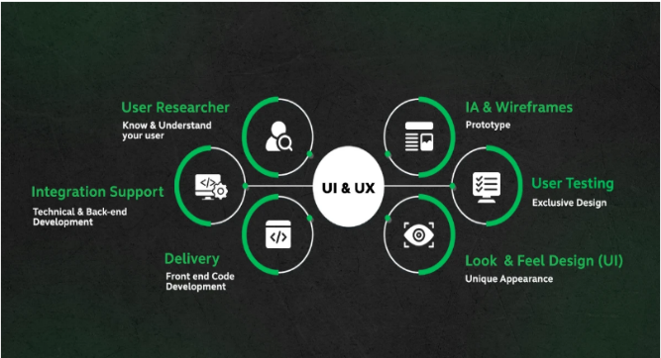

Their primary responsibilities revolve around ensuring a seamless and effective user experience

Their main roles are:

* User Research and Analysis
* Design and Prototyping
* Usability Testing
* Collaboration and Communication
* Accessibility and Inclusivity
* Iteration and Improvement
* The tools of UX:
* Wireframe
* The tools of UI:
* Figma

1. Development: It is considered the stage of implementing the project and developing or modifying it. It has two basic functions, which are:

* Front-end developers: work on the user interface and client-side logic. Focuses on layout, animations, content, organization, navigation and graphics. Below are the various responsibilities and roles of front-end developers:
* Front-end developers are experts in HTML, CSS, and JavaScript
* Responsive Design Implementation
* Modern front-end development often involves the use of JavaScript frameworks and libraries
* Collaboration with UX/UI designers is crucial
* Cross-Browser Compatibility Testing
* Performance Optimization
* Front-end developers use tools like Git to manage code changes
* Testing and Debugging
* The tools of front-end developer:
* Visual studio code
* Back-end developers: Backend developer responsibilities include creating, maintaining, testing, and debugging the entire back end of an application or system, and handle the server-side logic, databases, and integrations. Where it is focuses on building code, debugging and database management. Some of the most critical and typical roles for backend developers include the following:
* Software engineer
* iOS Developer
* Java Developer
* Backend Developer
* Full-stack Developer
* The tools of back-end developer:
* Java
* Python

1. Testing: It is very important to ensure that the software application meets the required specifications and works properly as it checks the design, codes and everything related to the project.

It includes several functions:

* Solution architect: A test solution architect fosters sustainable innovation by helping teams make the design choices that do two very specific things:

(1) Make test solutions easy to create and understand from the start, but that

(2) Continue to be the right choices to make those solutions easy to test, extend, and maintain as they grow larger.

The main role of solution architect is they design, describe, and manage the solution

* QA Engineer: plays a critical role in the quality assurance process. Their primary function is to ensure the program works as intended and doesn't have any bugs or other critical errors.
* The tools of QA engineer:
* Jira

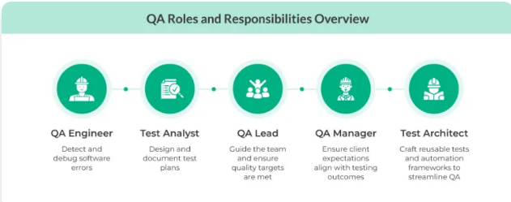

* Tester: Is not only to search for and report errors but also to ensure that the software operates as expected by users. Testers must have knowledge of the software development process, programming languages, and the ability to analyze requirements.

The main roles for the testers analyze the software’s usability, functionality, performance, etc., and help deliver a polished and error-free product for the end-users.

* DevOps: makes testing a shared responsibility of the entire team, while test automation enables developers to ship code changes quickly with high confidence in quality.

The main role for the DevOps is help teams rapidly and reliably deploy and innovate for their customers.

* The tools of DevOps;
* Git

1. Deployment: is preparation and procedures, product deployment, transferring ownership of the product, and closing the deployment phase. It has two basic functions, which are:

* Data Administrator: is the information technician responsible for directing and performing all activities related to maintaining and securing a successful database environment. A DBA ensures an organization's databases and related applications operate functionally and efficiently.

The roles and responsibilities of a DBA typically include the following:

* Database deployment and management
* Documentation and training
* Troubleshooting
* Backup and disaster recover
* Collaboration and integration
* Efficient database design
* Optimizing database performance
* Staying current
* Using the right tools
* User access and support
* Communication
* The tools of data administration:
* SQL server
* DevOps: is help teams rapidly and reliably deploy and innovate for their customers.

The role of DevOps deployment is develop and deploy their application and infrastructure code on the platforms

1. **Maintenance:** the software is monitored to ensure it continues to function as it was designed to, and repairs or upgrades are performed as needed.

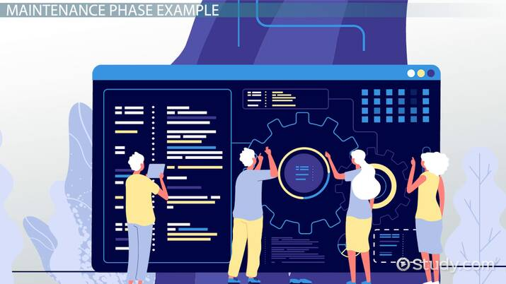

There are several functions that fall under it:

* Users: in Entire Operations, a user ID can be used to enter the system. Several users can log on to Entire Operations with the same user ID and password at the same time. For reasons of data security and in order to trace data modifications, however, each user usually has a personal user ID and password.

User roles are crucial for protecting sensitive information from unauthorized access. By assigning the appropriate roles and permissions, businesses can control who can view, edit, modify, or delete data. This granular level of control helps maintain data integrity and accuracy.

* Tester: evaluating and updating software to ensure it remains functional, secure, and efficient, even after changes or updates. The role of tester is to validate the system's features, capabilities, and interactions with different components.
* Support managers: is a professional responsible for overseeing the maintenance operations of a facility or organization. They are responsible for ensuring that all maintenance activities are completed in a timely and efficient

The role of support managers is manage and lead a team of customer support representatives, providing guidance, training and performance evaluation to ensure high quality service. Also supervises the team that interacts directly with customers and follows up on complaints, inquiries and all customer service related matters.

|  |  |  |
| --- | --- | --- |
|  | Input | Output |
| Analysis | Make a meeting with the client and explain to him how the project works and take from him the recommendations he needs to implement the project. | Project list to be implemented |
| Design | Drawing and designing the project according to the list of requirements | Final design of the project |
| Development | Implementation of the designed project | Coding |
| Testing | Test the codes if they work properly or not. | Follow up on the project in case of any problems or errors |
| Deployment | files code | Publish and distribute the project link on the website. |
| |  |  | | --- | --- | |  |  | |  |  |   Maintenance | Troubleshooting project errors or issues | New version of the project after modification |